Principles of Communications
Pulse Shaping & Matched Filtering

Aim of the Project
To study the principles of the Baseband pulse shaping and matched filtering.

Requirement of the Project
  - This project requires two students to work as a team. In case a team cannot be formed, one student working alone is also acceptable.
  - You must submit the electronic copy of lab report. The report should consist of answer to all the questions, simulation results, analysis and discussion.
  - Send the final project report to the TA’s email address with the subject “Lab3” .

Contents of the Project
Summary
This part of the lab will deal with pulse shaping in digital communication systems. You will implement the pulse shaping and matched filtering blocks of the baseband QAM modem shown in Figure 1 of Part 1.
We begin by discussing the motivation and mathematical model for pulse shaping. You will then build the pulse shaping, up-sampling, and matched filtering blocks of the modem in LabVIEW. After verifying the correctness of your design using a simulator, you will implement your code in lab using the NI-USRP to see how your code works over a real wireless link. The goal of Lab3 is to understand the motivation for pulse shaping and observe the properties of various pulse shaping filters.
In this lab, you will have to turn in two VIs (pulse shaping.vi and matched filtering.vi), and answer the questions given in Section 2, as part of the pre-lab submission.
- Pulse Shaping and Matched Filtering
The objective of the course is to construct the digital signal processing blocks necessary to operate a wireless digital communication link. A digital signal (from the digital source, constructed in Part 1 of Lab 1) cannot be transmitted over a communication channel. The digital signal needs to be mapped to an analog waveform that can easily be transmitted over the channel. The model for transmission and reception considered in Lab 3 is illustrated in Figure 1. The transmitter creates a complex pulse amplitude modulated signal of the following form:
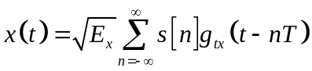
Conceptually, the mapping of bits to waveforms can be viewed in two steps.
1. Source bits to symbols—this involves mapping the bits emitted by the (digital) source to (possibly complex) symbols, s on a constellation, C determined by the modulation scheme. This was accomplished in Part 1 of Lab3.
2. Symbols to pulses—this involves creating an analog pulse train to be transmitted over the wireless channel, using the complex symbols generated in the first step. This is done using a pulse-shaping filter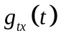at the transmit side.
The receiver processing depends on the type of distortion in the communication channel. Assuming an additive white Gaussian noise (AWGN) channel, the receiver performs analogous operations as at the transmitter.
1. Pulses to symbols—in this step, the symbols are recovered from the received pulses using a matched filter at the receive side.
2. Symbols to bits—this involves mapping the symbols received to bits (depending on the modulation scheme chosen), using some form of a detection technique. This was accomplished in Part 1 of Lab3 using the maximum likelihood detection algorithm.

To implement the maximum likelihood detector as described in Part 1 of Lab 3 using single-shot detection, the pulse shaping filters and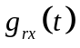have to satisfy some properties.
• The transmit pulse shape is normalized such that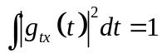. This is primarily for convenience in our notation to avoid additional scaling factors.
• The receive filter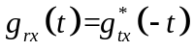, which simplifies to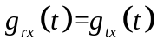 since the pulse-shaping function is usually real. This means that the receive filter is a matched filter. Effectively the filtering bybecomes a correlation withthanks to the relationship between convolution and correlation. The choice of a matched filter maximizes the received signal-to-noise ratio and thus gives the maximum likelihood detector its best performance.
• The composite filter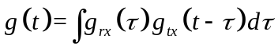 is a Nyquist pulse shape. This means that it satisfies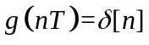. The Nyquist pulse shape property eliminates inter symbol interference, allowing the detector to take a very simple form as described in Part 1 of Lab 3.

Defining the bandwidth of the transmitted signal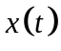requires some mathematical subtleties. From the perspective of measuring the power spectrum of a signal, the following definition of power spectrum for the transmitted signal is sufficient:
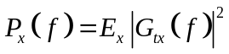
where it is assumed that the transmit constellation is normalized to unit energy. It is clear that 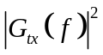determines the bandwidth of, where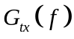is the frequency response of the pulse-shape. By normalizing the transmit pulse shape, 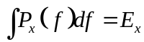where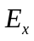is known as the symbol energy and Ex/T as the power.
A simple choice foris the rectangular pulse-shape. Unfortunately, such a pulse-shape would have poor spectral properties, since the Fourier transform of a rectangular function is a sinc function. This means that a lot of bandwidth would be required to transmit the signal.
Another choice foris the sinc function. A sinc pulse has ideal spectral properties. For example, if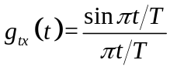then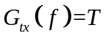for 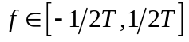giving an absolute bandwidth of 1/2T. This is the smallest bandwidth a complex pulse amplitude modulated signal could have with symbol rate 1/T. Unfortunately the sinc pulse shaping filter has a number of problems in practice. Ideal implementations of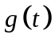 do not exist in analog. Digital implementations require truncating the pulse shape, which is a problem since it decays in time with 1/t. Further the sinc function is sensitive to sampling errors (not sampling at exactly the right point). For these reasons it is of interest to consider pulse shapes that have excess bandwidth, which means the double sided bandwidth of the pulse-shape is greater than 1/T.
  - A Common Pulse Shape
The most common Nyquist pulse, besides the sinc pulse, is the raised cosine. The raised cosine pulse-shape has Fourier spectrum
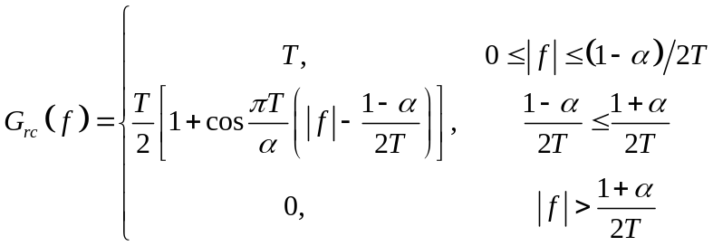
and transform
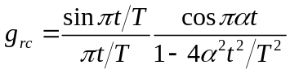
The parameter α is the rolloff factor, 0 ≤ α ≤ 1 (sometimes β is used instead of α) and is often expressed as percentage excess bandwidth. In other words, 50% excess bandwidth would correspond to α = 0.5. At large values of α the tails of the time-domain pulse decay quickly, but the spectrum roll off is smoother (i.e., it requires more excess bandwidth). Reducing the time-domain tails of the pulse shape reduces the amount of ISI introduced by sampling error. Thus rolloff factor α can be used to tradeoff excess bandwidth for resistance to ISI caused by sampling errors. The raised cosine pulse is illustrated in Figure 2.
The transmitter does not use the raised cosine pulse directly. The reason is that the raised cosine pulse shape corresponds to while we use at the transmitter andat the receiver. Recall theand that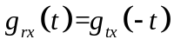. In the frequency domain this means that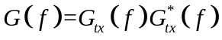. Consequently we choose to be a “square root” of the raised cosine. Such a pulse shape is known as a square root raised cosine, or a root raised cosine and is written
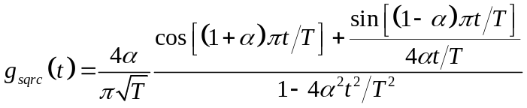
Of particular interest note that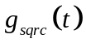is even, thus if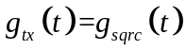then 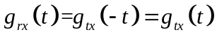and the transmit pulse shape and receive pulse shape are identical. The square root raised cosine is its own matched filter!
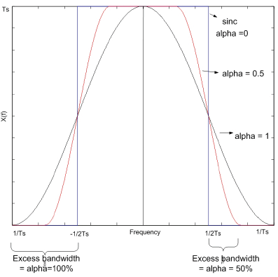
Figure 1: Spectral response of the raised cosine pulse shaping function g(t).

  - Practical Implementation of Pulse Shaping
Recall that the Nyquist theorem states it is sufficient to sample a given signal at a sampling frequency is at least twice the largest frequency in the signal, to be able to reconstruct the signal effectively. Sampling at a rate higher than what is required by the Nyquist theorem is known as oversampling. Oversampling at the analog front ends of a digital communication system (DAC and ADC) will make the design of all the filters much simpler. The increased bandwidth, due to a larger sampling frequency, will relax the sharp cutoff requirements on the filters needed to remove aliasing effects. Oversampling in digital systems is also important for efficient synchronization.
The upsampling and downsampling processes are critical in order to reap the benefits of oversampling. Upsampling a sequence {s[n]} by a factor L is equivalent to inserting L − 1 zeros between every sample of the sequence. Downsampling a sequence {y[n]} by a factor M is equivalent to throwing away M − 1 out of every M symbols (i.e.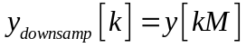). Upsampling and downsampling are used to facilitate the digital implementation ofand.
Simple explanations of transmit and receive pulse shaping using the concepts of upsampling and downsampling are provided in this lab. More efficient implementation computationally is possible using filter banks but that is not required to complete the assignment.
Transmit Pulse Shaping
The challenge with implementing transmit pulse shaping is that the symbol rate may be less than the sample rate required for pulse shapes with excess bandwidth. For example, for a square root raised cosine pulse shape, the Nyquist rate is (1 + α)/T while the symbol rate is only 1/T. Let Tx be some sampling period such that 1/Tx is greater than twice the maximum frequency of gtx(t). For simplicity we take Tx = T/L. Other choices of Tx would require a resampling operation. The continuous-time complex baseband signal is
Sinceis bandlimited by virtue of the bandlimited pulse shape, there exists a sequence {c[n]} such that
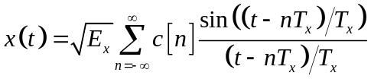
where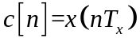. Substituting Eq. (3) gives
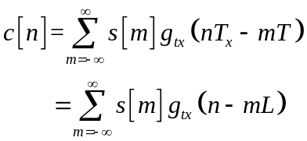
where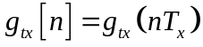. Using multi-rate signal processing identities, it can be shown that Eq. (4) is the result of upsampling s[m] by L, then filtering with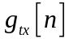.
Receiver Pulse Shaping
It is easier to justify the digital implementation of receiver pulse shaping. Let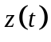denote the complex baseband input to the continuous-to-discrete converter. Assume thathas already been bandlimited by the RF in the analog front end. Let Tz = T/M for some integer M such that 1/Tz is greater than the Nyquist rate of the signal. This is known as oversampling. Let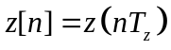. Using results on filtering bandlimited signals, it can be shown that
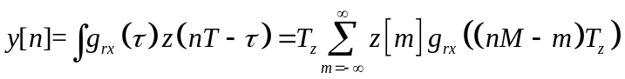
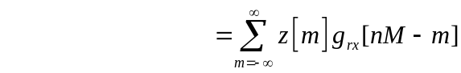
where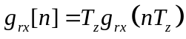.Using multi-rate signal processing identities, it can be shown that Eq. (6) is the result of downsampling the filtered oversampled signal z[n] by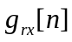.
  - Pulse Shaping in LabVIEW
LabVIEW provides many useful digital signal processing tools. In this lab, you will use MT Generate Filter Coefficients.vi, a Modulation Toolkit VI found in the Modulation palette (Function⇒Addons⇒Modulation⇒ Digital⇒Utilities⇒MT Generate Filter Coefficients.vi). This Modulation Toolkit VI allows you to generate a pulse shaping filter (e.g., root raised cosine) and its associated matched filter based on a set of input parameters. You will need to use this VI to build the pulse shaping and matched filtering blocks of Figure 1. The inputs to this VI [modulation type, pulse shaping filter, filter parameter and filter length (symbols)] can be obtained from the pulse shaping parameters available in the modulation parameters cluster. As a note about code style in LabVIEW, when building a VI requiring many inputs/outputs (i.e., about five or more of each), you should bundle related inputs/outputs into clusters. Clusters, found in the Cluster palette, allow you to group together terminals of different datatypes. For an example of a cluster you will be using in the lab, please look at the pulse shaping parameters terminal, which can be accessed from the front panel of top tx.vi.
- Lab Contents
To prepare for this part of the lab you will be required to build the pulse shaping and matched filtering blocks of Figure 1. Tables 1 and 2 describe the details of the VIs you must implement. You will plug your code into receiver.vi and transmitter.vi and run the simulator provided to you in order to verify functionality and correctness. Please name your VIs as per the convention your name VIname.vi. You have been provided with templates for the VIs you need to create for this lab that already have all the inputs and outputs wired for you. What is required of you is to finish constructing the block diagram to provide the functionality of the VIs. Throughout the course, several of the VIs you will create will have a modulation parameters cluster passed into and out of them. The modulation parameters in contains many of the parameters needed by your VIs and will be unbundled from them. This has already been done for you in the template VIs if necessary. Some VIs will also have modulation parameters out, so that the cluster can be passed on through to the VIs that follow. Please ensure that these clusters remain wired the way they are in the template VIs, as changing how they are wired will cause VIs further down the line to break.
You will be putting your VIs into transmitter.vi and receiver.vi, replacing the locked versions that are already there. After doing this, you will then open up simulator.vi,
Notice that pulse shaping.vi and matched filtering.vi do not take any parameters as inputs. All of the pulse shaping and oversampling parameters you need to use for these VIs can be accessed from the modulation parameters in cluster. After building these VIs, replace the existing code in the simulator with your code. Replace a subVI in the transmitter or receiver with your code by right-clicking on the appropriate VI and selecting Replace⇒Select a VI. Remember to wire error clusters where appropriate.
As described in the previous section, use MT Generate Filter Coefficients.vi from the Modulation Toolkit to generate your pulse shaping and matched filters. After generating each filter, you can apply the filter by convolving it with the complex array component of the appropriate input waveform. Do not use a Modulation Toolkit VI to apply either the pulse shaping filter or matched filter.
Table 1: Description of pulse shaping.vi
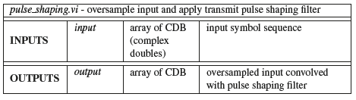
Table 2: Description of matched filtering.vi
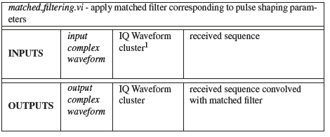
In LabVIEW, Convolution.vi, which is located in the Signal Processing tool palette (Functions⇒Signal Processing⇒Signal Operation⇒Convolution.vi), supports complex convolution. You can use this VI when creating your subVIs for this lab and others.
In summary:
• Use MT Generate Filter Coefficients.vi to generate the pulse shaping filter and its associated matched filters. Do not use Modulation Toolkit VIs to apply these filters. Instead, use convolution, and remember to make any necessary changes needed for complex convolution.
• The modulation parameters cluster contains many of the parameters needed for pulse shaping, including pulse shaping parameters, TX oversample factor, and RX oversample factor.
• After building pulse shaping.vi and matched filtering.vi, insert them into the simulator provided to you to verify functionality and correctness.
Using an Eye Diagram as an Analytical Tool
In this lab you will use an eye diagram to make some qualitative statements about the received signal. An eye diagram is constructed by taking a time domain signal and overlapping traces of a certain number of symbol times. For example, if Ts = 10 μsec is the symbol time for a given waveform, an eye diagram for an eye length of two would be generated by overlaying traces of duration 2Ts starting at an ideal sampling point. In the absence of noise, these overlapped signals might look something like Figure 2. The eye diagram of Figure 2 shows the overlapped traces of a BPSK modulated bit stream using a sinc pulse for an eye length of two. This eye diagram can give us some qualitative insight about our received signal. For example, the opening of the eye indicates the period of time over which we can successfully sample the waveform (i.e., without suffering from ISI). Along with indicating the amount of ISI in the system, the distortion of the signal in the diagram also indicates various qualitative parameters, such as the variation of zero crossings or distortion related to SNR.

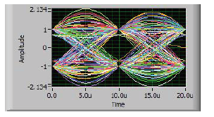
Figure 2: Eye diagram for sinc pulse shape in the absence of noise.
Questions
Answer the following questions, and submit the answers as part of your pre lab.
1. MT Generate Filter Coefficients.vi requires an input for the number of pulse shaping samples per symbol. This tells the VI the oversample factor being used to design the filter. When using this VI in pulse shaping.vi, where do you obtain this parameter from? Give any relevant cluster names and/or variable names if appropriate.
2. According to [1], impairments visible in the eye diagram can occur at many places along the communication path (i.e., from source to sink). What are some of the places where impairments visible in the eye diagram might occur (name at least three)?
3. When using inconsistent sampling rates at the transmitter and receiver, it is important to remember that the symbol rate (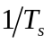) must remain constant.
(a) In terms of the sampling rates at the transmitter and receiver (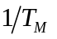and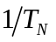respectively), what is the relation between the oversample factor at the transmitter (M) and receiver (N)?
(b) What can you say about the type of number the ratio of 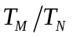 (i.e., the ratio of the sampling rate of the receiver to that of the transmitter) must be?
Hint: Note that M and N must be positive integers.
Turn In
1. Submit your implementation of pulse shaping.vi and matched filtering. vi. Remember, you will be penalized if you do not wire the error cluster inputs and outputs in your code.
Note: If you need to generate additional subVIs for this or any future labs, please submit these subVIs along with your other VIs.
2. Submit your answers to all of the questions in the section.

